Genki I & II

**Other:**

**ee – sound for past tense verbs**

# Random phrases

なので – since

みたいです – it seems that

# Lesson 1

## X は Y です

## Question Sentences

## Noun1 の Noun2 - Connect two nouns

Useful Expressions:

Time

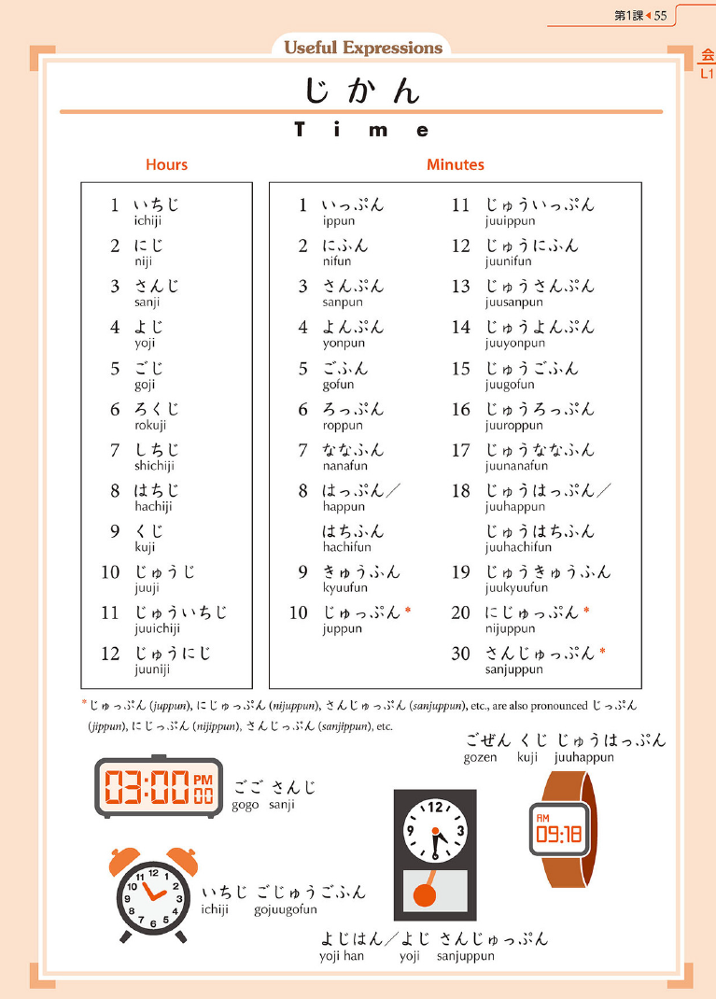

# Lesson 2

## これ / それ / あれ / どれ

**これ -> This one [near me] (n.)**

**それ -> That one [near you] (n.)**

**あれ -> That one [over there] (n.)**

**どれ(が) -> Which one [interrogative, unspecified] (n.)**

## この / その / あの / どの + Noun

**この -> This (adj.)**

**その -> That (adj.)**

**あの -> That [over there] (adj.)**

**どの(が) -> Which (adj.)**

## ここ / そこ / あそこ / どこ

**ここ -> Here**

**そこ -> There [near you]**

**あそこ -> There [away from us]**

**どこ(が) -> Where**

## だれの Noun – Whose

**だれ　・　だれの (が)**

**Who Whose (adj.)**

## Noun も- This too

## じゃないです - negate

## ～ね /　～よ – seek agreement / I tell you (fully confident)

# Lesson 3

## Verb Conjugation

## Verb Types and “Present Tense”

## Particles

## Time References

day of the week + に

time + に

No に needed for:

* present moment expressions: today, tomorrow
* regular intervals: every day
* asking “when”

Not needed for the following but can be used to add emphases, personal preference:

* parts of day: in the morning, at night
* the weekend

## ～ませんか (extend invitation)

## Frequency Adverbs

## Word Order

## The Topic Particle は

# Lesson 4

## X があります / います

## Describing Where Things Are

## Past Tense of です

## Past tense of verbs

## も – two or more people perform the same activity

## 一時間　（いちじかん） - duration of an activity

## たくさん – expression of quantity

## と – Connect two nouns & “together with”

# Lesson 5

～ましょう/ ～ましょうか - Lets

～まで – to (a place), as far as (a place), till (a time)

## Adjectives (Present Tense)

## Adjectives (Past Tense)

## Adjectives (Noun Modifications)

## すき(な) / きらい(な) – like/dislike

## ～ましょう/～ましょうか

## Counting

# Lesson 6

## て-form

## ～てください (Polite request, please do for me)

## Describing Two Activities

## ～てもいいです (You may do, activity that is permitted)

## ～てはいけません (You must not do)

## ～から (Because)

## ～ましょうか (Offering Assistance)

# Lesson 7

## ~ている (action in progress)

- conjugates like a る-verb

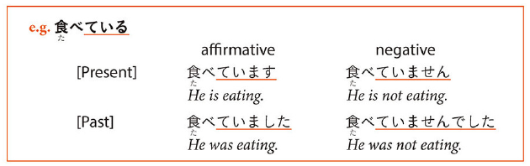**verb stem + にいく**

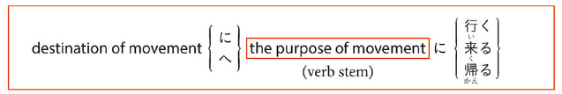

**Stems:**

## 

## ～ている (Result of change)

## メアリーさんはかみがながいです (Describe somebody)

## Adjective/Noun Te-forms for joining sentences

## Verb Stem + にいく (purpose of movement)

## Counting People

# Lesson 8

## Short forms

## Short forms in informal speech

## Short forms in quoted speech: ～ておもいます (describe what you think)

## Short forms in quoted speech: ～ていっていました (quote someone else, else’ utterances)

## ～ないでください (request someone to not do something)

## Verb のがすきです / じょうずです (describe what you like/dislike doing)

## The Subject Particle が

## なにか and なにも (something / anything)

# Lesson 9

## Past Tense Short Forms

## Past Tense Short Forms in Informal Speech

## Past Tense Short Forms in Quoted Speech: ～とおもいます　(I think that, report what you think took place in the past)

## Past Tense Short Forms in Quoted Speech: ～といっていました (heard somebody say a sentence)

## Qualifying Nouns with Verbs and Adjectives

## もう～ました and まだ～ていません (event that happened at a certain time)

## Explanation から, situation

# Lesson 10

～つもりだ – intend to do, plan to do, intention

3 -adjective/noun + の- avoid repetition, refers to person mentioned previously

To become

Comparison

## Comparison between Two Items

## Comparison among Three or More Items

## Adjective/Noun + の (clear on what is being refereed to)

## ～つもりだ (person planning to do in the future)

## Adjective + なる (to become, indicating a change)

## どこかに/どこにも (other expressions for some and many)

## で (means of transportation and instruments used)

# Lesson 11

3: ～ことがある(experience of, something happened, earlier time, I have ‘never’ done that)

たいです/たくない – hope or aspiration, I want

たり, たりする: make a list, not only things intend to do

## ～たい (Hope or aspiration)

## ～たり～たりする (do event as example, not specific order)

## ～ことがある (you did something, something happened in earlier times)

## Nouns A や Noun B (things are proposed as examples)

# Lesson 12

～んです – to explain

**Must**

すぎ(たので)/ すぎる – too much

## 3 ～ほうがいいです(Better for you…)

-ないほうがいいですよ

~ので:

なので – since

な at the end of な adjective before ので so なので

## 5- なければいけません/なきゃいけません (must/needs to)

## ～んです (statement to explain things)

## ～すぎる (too much, to excess)

## ～ほうがいいです (it is better (for you) to do)

## ～ので (give reason for situation)

## ～なければいけません / ～なきゃいけません (necessary to do something, something must be done)

## ～でしょうか (tentative question, not embarrassed when someone does not know the answer to a question, show politness)

# Lesson 13

1: Do something for me, show something to me くれました

**～し(end of sentence)**

* Mention two or more reasons
* Using one **し** clause implies it is not the only reason
* Sometimes they follow the situation that is being explained
* **し** follows the short forms (except in very polite speech)
* **い** adjective: **面白いし**
* **な** adjective: **好きだし**
* Noun +**です**: **学生だし**

**～そうです** (It looks like)

い-adj: remove い -> replace with そう

* Add **そうです** to adjectives to say something “seemingly” has those properties
* **そうです** is used when you lack conclusive evidence.
  + Before eating: **おいしそう**​→​After eating: **おいしい**
* Using a verb stem with **そうです** describes:
  + Your impression or guess
    - **このセーターはいえで洗えそうです**
  + Impression you express may be an event about to happen
    - **雨が降りそうです** ​←​It looks like it will rain
* Negative ending **ない** changed to **なさ** before **そう**
  + You can also put the negative on **そうです** instead of an adjective
    - **この本は難しそうじゃないです**
* Using adjective + **そう**qualifies a noun. **そう** is considered a **な**-adjective so you have to say (adjective)**そうな**(noun).
  + Example: **暖かそうなセーターをきています** ​←​She is wearing a warm-looking sweater

**～てみる**

Use **て**-form of a verb and **みる** (helping verb) to express the idea of “doing something tentatively” or “trying something out”.

The helping verb **みる** comes from the verb **見る** and conjugates as a regular **る**-verb. It is ​*always* written in hiragana

​**なら**

* Noun A **なら** predicate X = predicate X applies only to A
* You can keep **に**, **で**, and **から** but **は**, **が**, and **を**, never go with **なら**
* Main ideas of a **なら** sentence are
  + Contrast
    - **チリなら行ったことがありますが、ブラジルは行ったことがいません**
  + Limitation
    - **ひらがなならわかります**​→​if it is written in hiragana, I understand
* **なら** introduces a sentence that says something “positive” about the item that is contrasted.

## Potential Verbs

## ～し(mention more than two reasons)

## ～そうです (it looks like)

## ～てみる(doing something tentatively, trying something)

## なら (Y only applies x, not general)

## いっしゅうかんにさんかい (frequency of events over period of time)

# Lesson 14

Chapter 14 し and negative

I want – ほし

## 3 – あげる・くれる・もらう

もらう- to receive

くれる- to give (remove ru for ends of sentences)

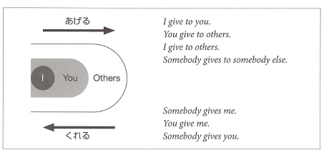

**ほしい**

* Means (I) want (something).
* Considered an **い**-adjective and is usually preceded by the particle **が**. In negative sentences **は** is also used
* It is similar to **たい**in that its use is primarily limited to first person.
* To express it applied to second or third person:
  + Quote
    - Ex. **ロバートさんはパソコンがほしいと言っています**
  + Guess
    - **きょうとさんはクラシックの**CD**がほしくないでしょう**
  + Special verb
    - **ほしがる**. Conjugates as **う**-verb and usually is in the form **ほしがって**

**いる**. The particle after the object is **を**.

o **トムさんは友だちをほしがっています。**

Potential Verbs

* They conjugate as **る**-verbs
* Particles that take particle **を**can take either **を** or **が** when in potential form. **できる** takes **が** almost all the time

|  |  |  |  |
| --- | --- | --- | --- |
| Examples: **私は日本語を話せる** | | | **漢字が読める** |
|  | **私は泳げないんです** | | **山に登れる** |
|  | **仕事ができる** | |  |
|  |  |  |  |
| Verb |  | Present |  |
| **る** | **＋られる** | **見られる** |  |
|  |  |  |  |
| **う** | **＋える** | **読める** |  |
|  |  |  |  |
| **くる** |  | **こられる** |  |
|  |  |  |  |
| **する** |  | **できる** |  |
|  |  |  |  |
|  | **ら**-less |  |  |
|  | potential |  |  |
|  | form |  |  |
| **出る** | **出れる** |  |  |
|  |  |  |  |
| **くる** | **これる** |  |  |
|  |  |  |  |

**～かもしれません**

* May not
* Short form: **かもしれない** or simply **かも**
* Means that something is a possibility; when you’re not really sure but are making a guess
* It goes after the short form of predicates
* It goes directly after the noun or **な**-adjective in present tense affirmative sentences (no **だ**)

## ほうし (I want something)

## ～かもしれません (it is a possibility)

## あげる/くれる/もらう (giving)

## ～たらどうですか (advice or recommendation)

## Number + も/Number + しか + Negative

# Lesson 15

Intention/plan/intend to do:

Volitional Form

* Less formal equivalent of **ましょう**
* Use it with **か** to ask for an opinion in offer or suggestion (Shall)

Volitional Form + **と思っています**

* Talk about determinations. “I’ve decided to/ I’m going to”
* **と思います** suggests decision was made on the spot
* **と思っています** suggests you have already decided to do something
* Using present tense= talking about prediction. Using volitional= talking about intention

**～ておく/ In advance**

* Describes an action done in preparation for something
* Short form + **て**. Often shortened to **とく** in speech
* Ex. **あした試験があるので、今晩勉強しておきます**

## Volitional Form (suggest plan to close friend)

## Volitional Form + とおもっています (talk about resolution)

## ～ておく (action performed in preparation of something)

## Using Sentences to Qualify Nouns

# Lesson 16

## ～てあげる/てくれる/てもらう (helping verbs, giving or receiving of services)

## ～ていただけませんか (Make a request, different degrees of politeness)

## ～といい (Hope something nice happens)

## ～時(とき): (While/When something happens / Describe when something happens or happened)

Short form + とき

## ～てすみませんでした (Describe things you have done that you want to apologize for)

# Lesson 17

Phrases:

かな~ I wonder

## 1: ～そうです (I hear) – I have heard that this thing is….

* Add to end of short form sentence

## 2: ～って – quote what you have heard

## 3: ～たら - B is valid only if A is fulfilled

* A たら B
* だったら
* The initialたinたらcomes from the short form past tense endings of predicates (main verb)

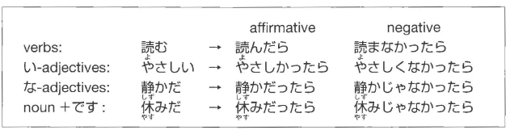

## 4: ～なくてもいいです – do not need to do

* Negative short form, drop final い



## 5: ~みたいです – resembles someone / looks like someone / acts like / it seems that

## 6: ～前（まえ）に／～てから – event before something happens

* Present short form



* After event happens: te-form + から



# Lesson 18

## 1 - Transitivity Pairs

Humans act on things / changes that people or things undergo:

Transitive (activities): Subject (agent) + object (thing worked on)

Intransitive (changes): only subject (thing goes through change)

## 2 ～てしまう

Te-fom + しまう

1: “one carries out with determination”

2: “lack of premeditation or control over how things turn out” (sense of regret/not intend to do)

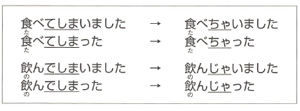

## 3 ～と

Present tense form of a predicate + と: situation described by the predicate holds

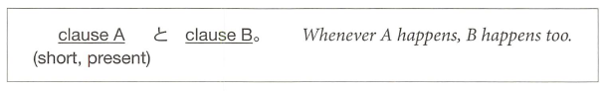

* cause とeffect.

## 4 ～ながら

Connect 2 verbs to say 2 actions performed at the same time

* word stem + ながら (2nd verb {verb after ながら} can be in any form)
* verbstem 1 (u sound -> i sound) + ながらverb 2

## 5 ～ばよかったです

I wish I had done / I should have done something

* describe alternate course of action/regret
* 

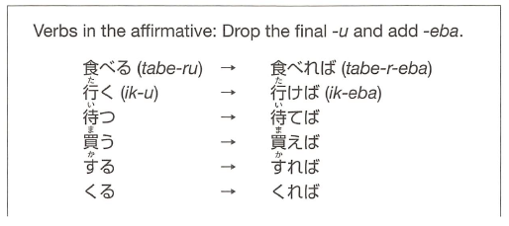

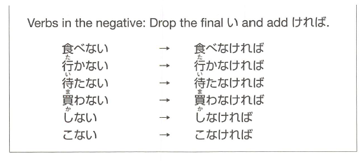

# Lesson 19

## Honorific Verbs / Graciously

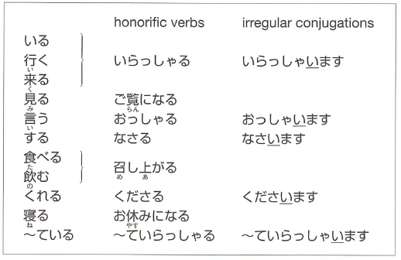

Honorific verbs are not available:

1. ていらっしゃいます instead of ています(if the sentence has the helping verb ている)



* Keep conjugation form example:

社長はたばこを吸います -> 社長はたばこをお吸いになります

おすいになります

* Not すうbut すい (verb stem, conjugated to ‘ee’ sound) as conjugated in the original
* した might become った
  + If it appears that end of a sentence (or with a ‘but’ ~ が’) is した
  + する (なさる) is always なさった

## Giving Respectful Advice

お + verb stem + ください

* するuse ご instead of お

Special honorific verb examples:

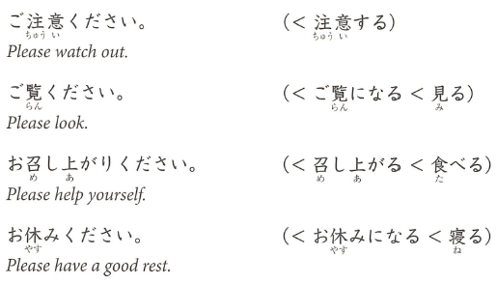

## 3 ～てくれてありがとう

* Express gratitude to someone
* Refer to specific action that you are grateful for

Te form + くれてありがとう



* When honorific is needed (you are not close or social hierarchy)
  + Te-form + くださってありがとうございました

## 4 ～てよかったです

**Xがあります/ います – there is**

* Te-form + よかった: “I’m glad that such and such is/was the case”
  + Negative：te-form なくて
  + Negative te-form reminder: only use the なくて…



“thank you for being such-and-such a person”

* Use でいる instead of です

For giving a reason

* Use the because part (usually second in English) as the first part with dictionary form then the first part afterwards

## 5～はずです

* Sentence ending in short form + はずです: Something is “supposed to be the case”
* What you believe is true/is the case, lack conclusive evidence

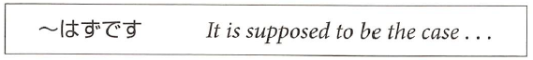

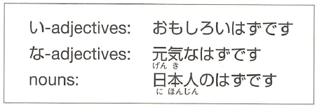

* If present keep する as する and not した
* With potential form keep in ...る form and don’t conjugate

Past tense:

* Something that was supposed to be the case but turned out to be otherwise
* Present tense + はずでした

Negative:

* Negative verb + …たはずです

Something is inconceivable:

* はずがありません and はずがない
* “I cannot imagine”

だったん - was

# Lesson 20

## 1. extra modest expressions

[**https://sethclydesdale.github.io/genki-study-resources/lessons/lesson-20/grammar-1/**](https://sethclydesdale.github.io/genki-study-resources/lessons/lesson-20/grammar-1/)

* Talk modestly of our own actions
* Verbs usually in long form
* Ends sentence with ‘sir’ or ‘ma’am’

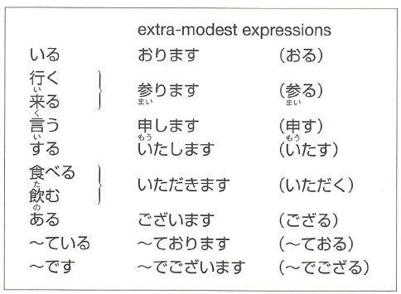

Used to lower your status and elevate the **listeners** status.

From sentences:

V:

今年 [ことし] - this year

N:

卒業 [そつぎょう] – graduation

文化 [ぶんか] – culture

興味 [きょうみ] – interested in something

階 [かい] – story / floor

Phrase:

一年間 [いちねんかん] – period of one year

来年 [らいねん]- next year

examples:

私は来年も日本に **おります**。 (います => おります)

(I will be in japan next year too)

私は今年の六月に大学を卒業いたしました。

I graduated from college this June, sir/ma’am.

お手洗いは二階 **でごいざいます**。 (です => でございます)

(The bathroom is on the second floor)

## 2. humble expressions

To lower your own status and raise the **subject** in your sentence's status

general form:

**お + (verb masu stem) + する。**

for **~する** verbs, usually **ご** instead of お

example:

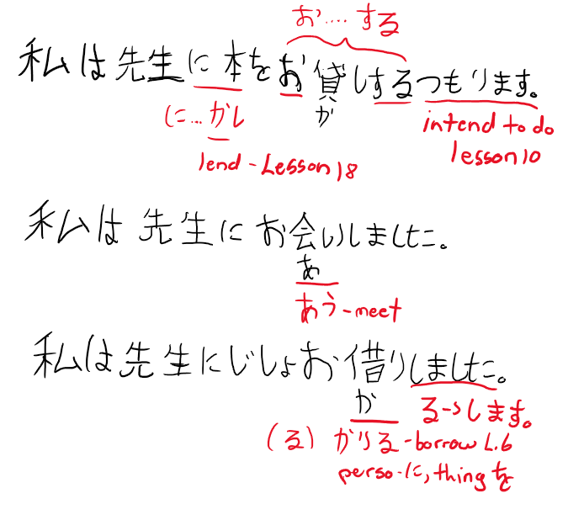

Lend – lesson 18, intend – lesson 10

## する compound verbs, only have ご or お

お/ご + noun + する

**for もらう (to receive – L.14), => いただきます**

**for あげる (to give – L.14), => さしあげる**

**with verb (humbly did an action) て- form+いただきます (did for me)**

**うかがう – humbly visit and ask questions**

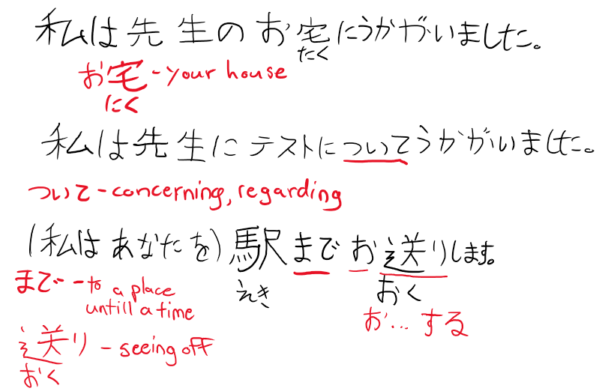

example:

私は先生に花を **さしあげます。**

(I will give my professor flowers)

use the verb **うかがう** to be humble in both visiting and asking questions.

example:

私は先生のお宅に **うかがいました**。

(I visited my professors house)

私は先生にテストついて **うかがいました**。

(i asked my professor about the exam)

note that the extra modest form raises the **listeners** status, whereas humble form raises the **subjects** status (for example the sensei u are referring to in ur sentence)

## 3. without doing X

**verb + ないで = without doing X**

Missed action as ~ない (short negative present) + で

Present form of ~ない for present and past

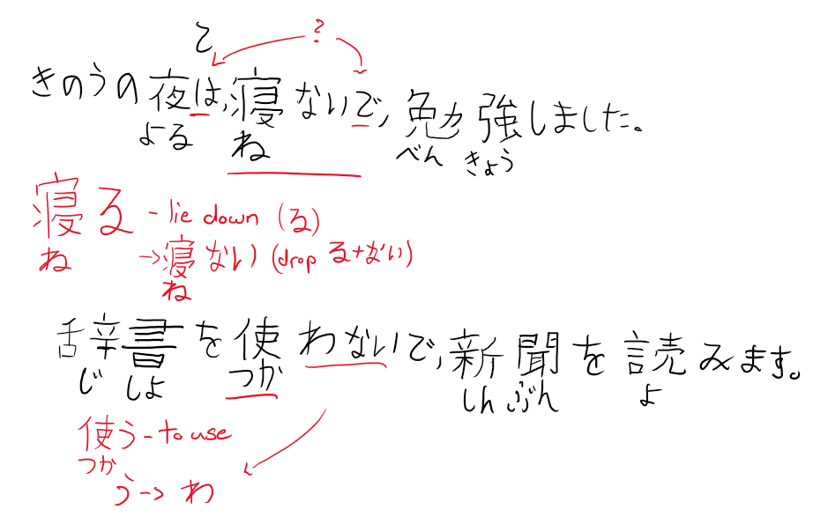

example:

昨日の夜は、**寝ないで**、勉強しました。

(last night, i studied without any sleep)

## 4. questions within larger sentences

you can include questions within larger sentences.

* Quoted questions in short form
* Clause ends with か when it contains だれ or なに
* Clause ends with かどうか when it does not contain a question word

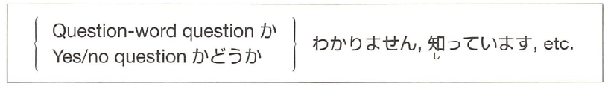

か:

Do you know if…./can/is (currently in the process of..)/where/what…

かどうあ:

Do you know if…. Likes/good at/…

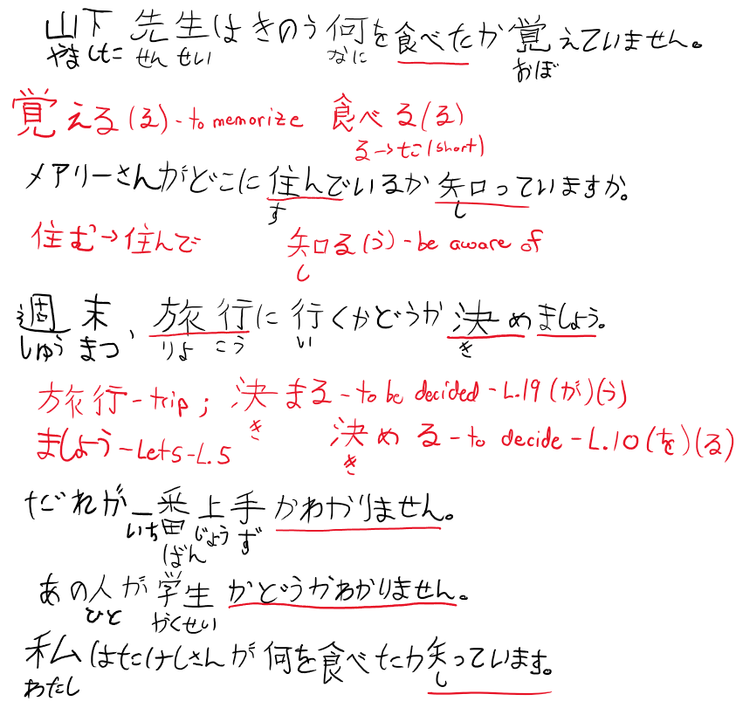

## 5. the name of objects.

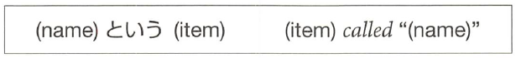

example:

**ポチという犬**。 (the dog called "pochi")

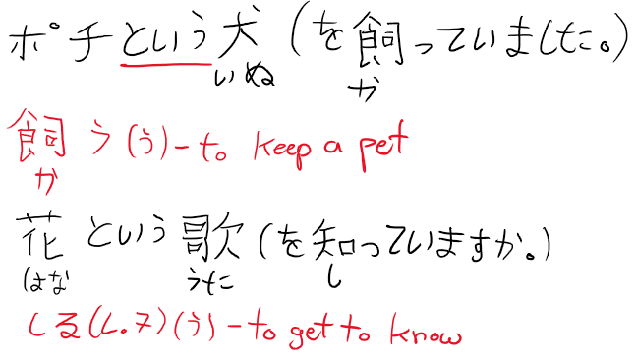

## 6. easy/hard to do

(verb masu stem) + **やすい/にくい** = (verb) is easy/hard to do.

* Easy: verb stem + やすい conjugate like い-adjective
* Hard: verb stem + い-adjective form of にくい
* Place something is easy/hard to do in
* Tool easy/hard to do something with

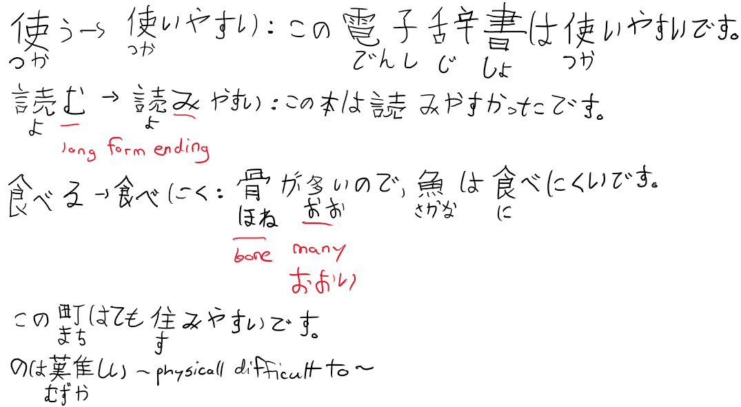

examples:

この電子辞書は**使い やすいです**。

(this electronic dictionary is easy to use)

骨が多いので、魚は**食べ にくいです**。

(because there are many bones, fish are hard to eat)

この町はとても **住みやすいです**。

(this town is very easy to live in)

note that it refers to the psychological state of whether it is easy/hard to do

example:

この雑誌は **買いにくい**。

(this magazine is hard to buy. (because im embarrassed by its contents))

vs

この雑誌を **買うのは難しい**。

(this magazine is hard to buy. (because it is rare and hard to find in circulation)

# Lesson 21

## 1. Passive sentences / inconvenienced by something / bothered by

Passive sentence:

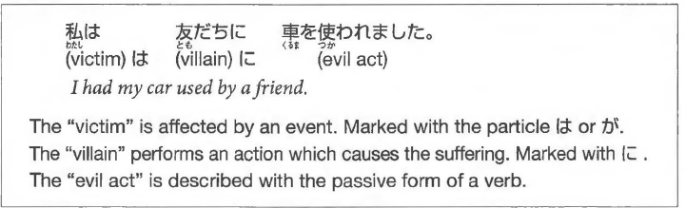

general form:

**X は Y に (verb passive form)**

= X had (verb) done to him by Y.

Passive Forms:

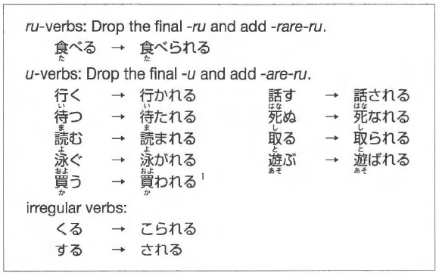

うending becomes ‘w’ (う -> わ) like negative short form

Passive forms ofるand くる are the same as potential form (lesson 13)

Passive formう is different than potential form

Passive forms conjugate as regular る-verbs (including う):

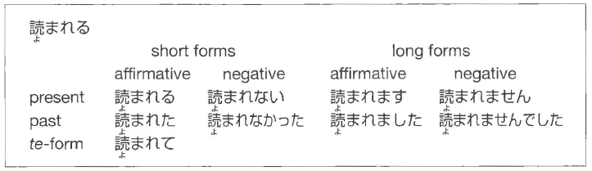

Used for being: angry, embarrassed, sad, and hurt

NOTE: Only used for verbs and not adjectives

* + Situations where something took place due to an action, not that something is described as ‘bad’

Example Sentences:

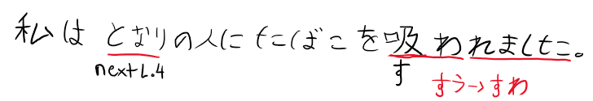

I was annoyed with the person sitting next to me for smoking.

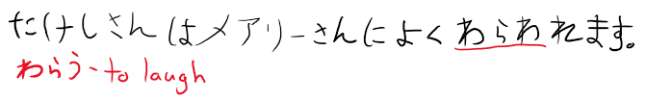

Takeshi is often laughed at by Mary.

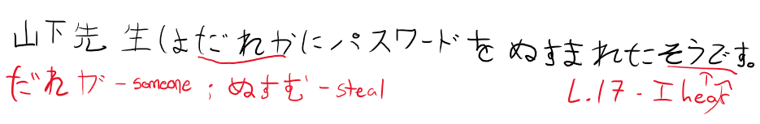

I hear that Professor Yamashita had his password stolen by someone.

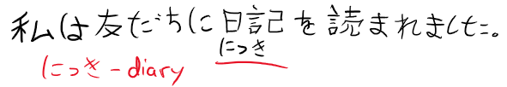

I was annoyed with a friend of mine for reading my diary.

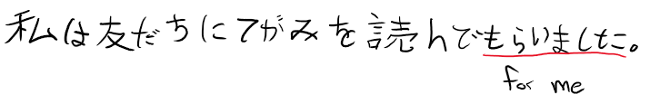

I had a friend of mine read the letter for me.

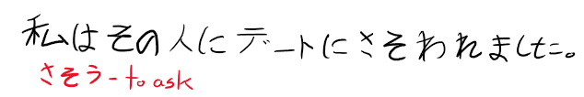

I was asked out by that person for a date.

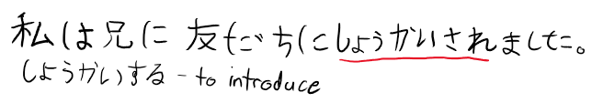I was introduced by my big brother to a friend of his.

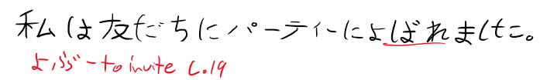I was invited by a friend to a party.

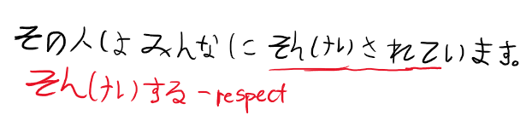

That person is looked up to by most everyone.

Side note:

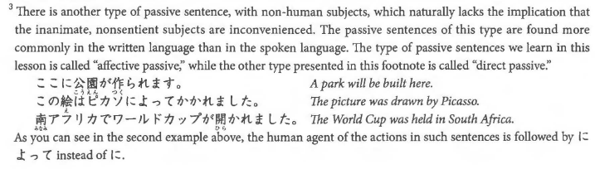

## 2. てある - situation that has been brought about on purpose (person remains unnamed)

て-form + ある (helping verb)

が – used for most of them instead of は

Sentences:

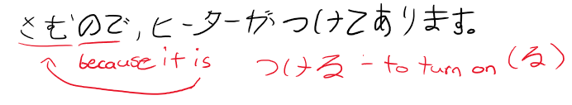

The heater is on, because it is cold.

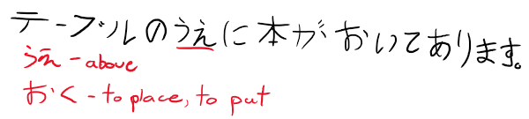

A book is on the table.

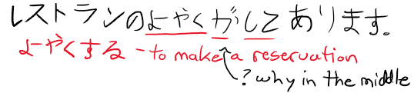

A restaurant reservation has been made.

- It is using reservation not ‘to reserve’ so no する.

its kind of like an intransitive form of **ている**。

also implies that something has been brought about **on purpose** by somebody.

example:

窓 が **閉めてあります**。

(the window is closed (by somebody, and is still closed till now))

vs

窓 が **閉まっています**。

(the window is closed (just a statement that it is closed))

## 3. ~間に ->（あいだ）に ~ event takes place in middle of another event

A 間に B – event B takes place in the middle of another event A

Event A described with continuous form ている

- verb A is always in the present tense



A – can be a noun or verb

B – must be short and can happen within A boundaries

If B happens throughout the time A occurs, then:

間に become 間 (drop the に)

Sentences:

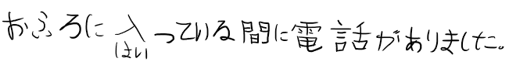There was a phone call while I was taking a bath.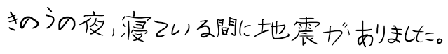 There was an earthquake while I was asleep last night.

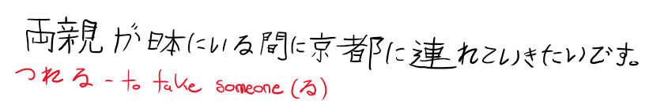

I want to take my parents to Kyoto while they are in Japan.

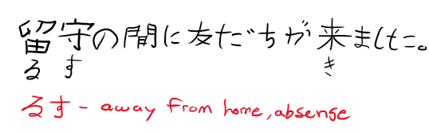

A friend came while I was out.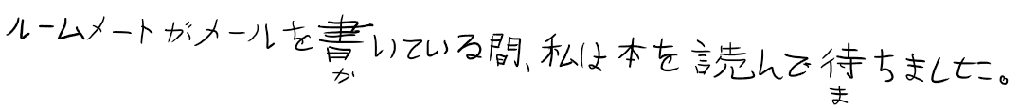 I waited, reading a book, while my roommate was writing an e-mail.

general form:

A (ている

) **間に** B.

(in the middle of/while A, B)

example:

お風呂に入っている **間に** 電話がありました。

(there was a phone call while i was taking my bath)

A can be a noun:

example:

留守の **間に** 友達が来ました。

(while i was absent, my friends came)

for the above, B lasts for a short duration. if B extends throughout the time A occurs, use **間**

example:

ルームメートがメールを書いている **間**、 私は本を読んで待ちました。

(while my roommate was writing a mail, i waited, reading a book)

## 4. adjective + する: “to make”

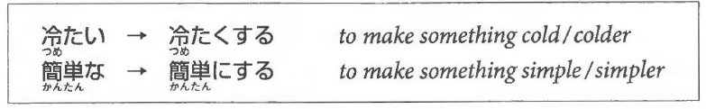

- become good/better at doing X

-い ->く

- な ->に

(adj) + **する** =  to make something (adj)

similar to **なる** and its conjugations too.

i adj:

冷たい => **冷たくする**。

(to make something cold/colder)

na adj:

簡単な => **簡単にする**。

(to make something simple/simpler)

example:

部屋を **きれいにしました**。

(i made the room clean)

**Sentences:**

Please make the next exam easier, because the last one was too difficult.

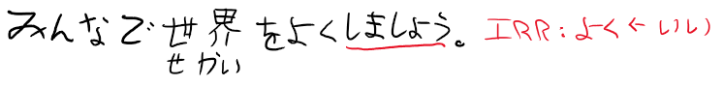

Let's join our forces and make the world a better place.

I made the room clean.

I want to make my hair like Bob Marley's.

## 5. ～てほしい: “I want him to do...”



- describe your wish

**Don’t want someone to do something:**

- negate ほしいand say ～てほしくないです

OR

- negate the verb and say ～ないでほしいです．

**Sentences:**

**(私は) person に (verb) て欲しい。**

= i want person to do (verb)

example:

私 は ルームメート に 宿題を**手伝って欲しい**です。

(i want my roomate to help me with my homework)

u can say i dont want him to do X by negating the 欲しい to **欲しくない** or by making the verb negative + 欲しい。

# Lesson 22

## Causative sentences

- Who makes/lets someone do something

- If helping verb: てあげる・てくれる・てもらう follows causative verb, it is the “let” clause

- causative + てください to ask for permission/volunteer

- Use を instead of に when:

- the action is a reflex: crying and laughing

- if a verb does NOT originally use を

## 2. verb stem+なさい(command)

なか

**(verb masu stem) + なさい** = a command to do (verb).

“don’t do…” – verb + のをやめなさい

やめなさい comes from やめる(to stop)

- may sound like u are "talking down" to somebody.

- think you are more mature/know better/should be obeyed

- parents use towards children/teachers use towards students

うちに毎日　電話しなさい。

まいにち　でんわ

Call home every day.

かっこの中に単語を入れなさい。

なか たんご　 ぃ

Fill in the blanks with a word.

文句を言うのをやめなさい。

もんく　い

Stop complaining.

## 3. ~ば conditional (if A, then B)

**A ば B** = If A, then B.

A - condition where B must follow

B - consequence described

A guarantees a good result in B

Used to advise A

B can contain expression like 大丈夫です orいいんです

　だいじょうぶ

車があれば、いろいろな所に行けます。

くるま　　　　　　　　　　　ところ　い

If you have 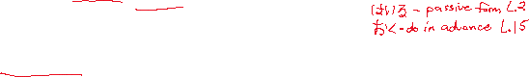a car, you can go to various places.

かぎをかけておけば、どろぼうに入られません。

　　　　　　　　　　　　　　　　　　　　はい

If you lock the doors and windows, you won't have your apartment broken into.

大家さんに言わなければ、わかリませんよ。

おおや

If you do not tell the landlord, he will never find that out

走れば、霊車に間に合います。

はし　　　でんしゃ　ま　　あ

If I run, I will be able to catch the train.

この薬を飲めば大丈夫です。

　　くすI) 　の　　 だいじょうぶ

You will be okay, if you take this medicine.

先生 に　聞　けばいいんです。

せんせい　　き

All you have to do is ask the teacher. (If you ask, everything will be fine.)

## 4. ～のにdespite

(short form A) **のに** B

= despite the fact that A, B.

both A and B must be **facts**

**-** If A ends with な or noun+です it appears (with?) な similar too んです.

example:

この会社はお金がある **のに**、給料は安いです。

(Although the company is rich, the workers salaries are low)

when A ends in な adj or noun, add a な at the end of A to become **なのに**.

この会社はお金があるのに 給料 は安いです。

　　　かいしや かね きゅうりよう やす

This company is rich, but its workers salaries are low.

家にいるのに、電話に出ない。

いえ でんわ　 で

She is home but does not answer the phone.

田中さんは親切なのに、山田さんは田中さんがきらいです。

たなか しんせつ やまだ たなか

Ms. Tanaka is nice, but Ms. Yamada does not like her.

大きい問題なのに、あの人はだれにも相談しません。

おお もんだい ひと そうだん

It is a big issue, but he does not consult with anybody.

## 5. ～のような／～のように(is like / do something like...)

(noun A) **のような** (noun B) = A is similar to/like B (in appearance/quality)

- みたい (Lesson 17) used in the same way except の is not used

私 は 鎌倉 のような町が好きです。

わたし かまくら まちす

I like towns like Kamakura.

私 はアウンサン・スーチーのような人になリたいです。

わたし ひと

I want to be a person like Aung San Suu Kyi, the Burmese democracy leader.

メアリーさんは魚のように上手に 泳げます。

さかな じょうず およ

Mary can swim very well, just like a fish.



アントニオさんは孫悟空 のように強いです。

 そんごくう 　つよ

Antonio is strong like Son Goku.

この町は夜の墓場のように静かです。

まち よる はかば しず

This town is as quiet as a graveyard at night.

あの人はマザー・テレサみたいな人です。

ひと ひと

She is a person just like Mother Teresa.

あの人は 壊れたレコードみたいに同じことを言います。

 ひと こわ おな い

She says the same thing over and over again, just like a broken vinyl record

# Lesson 23

Summary:

1. Causative-passive Sentences

2. Even if.. with ても

3. Decide to do…with ～ことにする

4. Decide your habits… with ことにしている

5. Until…with ～まで

6. Methods with 方（かた）

## 1. Causative passive sentences (made to do, harassed, talked into doing something you don’t want to do)

Causative (Who makes/lets someone do something)

Passive (inconvenienced by something / bothered by)

- Passive ending – lesson 21

Causative-passive Sentences

* the passive version of causative sentence
* Made to do / harassed / talked into

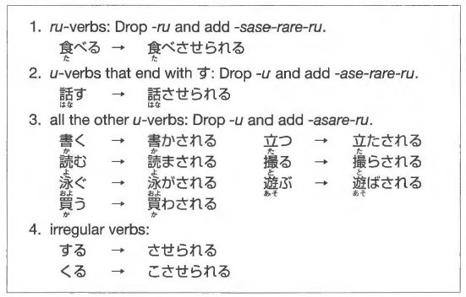

Expected form:

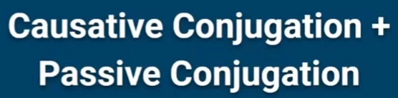

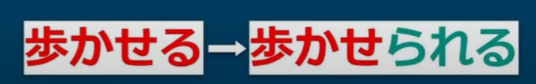

passive ending - lesson 21

* correct but not common

More common:

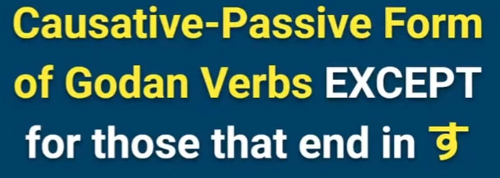

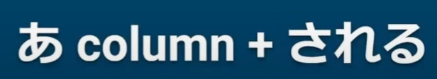

Example:

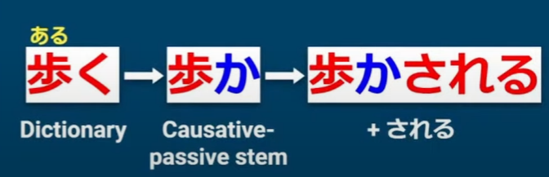

Ru-verbs:



same as: causative + passive

たべる-> causative たべさせる

たべさせる -> drop るadd passive (られる)

たべさせられる

Sentence structure:

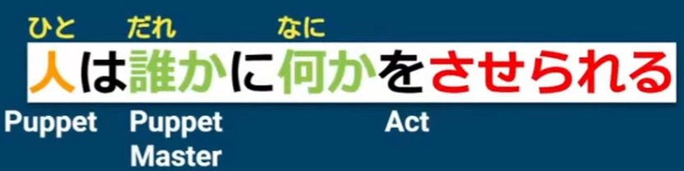

## 2. Even if.. with ても

**A ても、B = even if A, B**

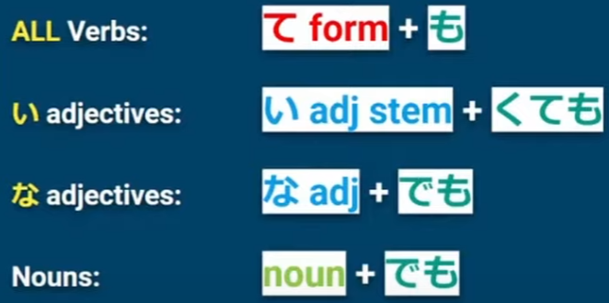

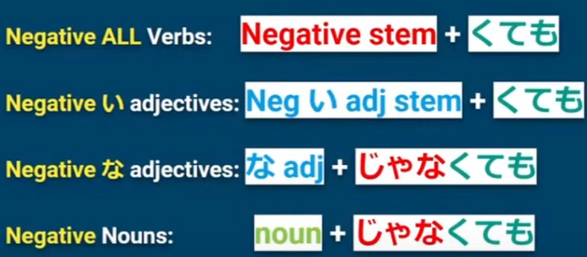

Form in Lesson 6.

いいよ

Lesson 23.

ても

(い-adj: ending い -> く)

## 3. Decide to do…with ～ことにする

(verb short form present tense) + **ことにする** = decide to do (verb)

everything before the こと is turned into a noun

example:

車を買う**ことにしました**。

(we have decided to buy a car)

sometimes volitional form is used eg. **行くことにしましょう**。

Also means lets do (verb), but has implication that u gave some **deliberation**.

(verb) + **ことにしている**

= do (verb) as a **regular practice.**

example:

絶対にお酒を **飲まないことにしています**。

(i have made this firm decision not to drink alcohol and have strictly followed it)

## 4. Until…with ～まで



**A まで、B = until A, continue B.**

example:

晴れる **まで**、喫茶店で待ちます。

(until the sky is clear, i will wait in the coffee shop)

## 5. Methods with 方（かた）

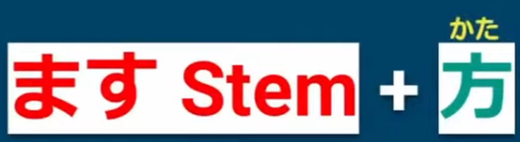

(verb masu stem) + **方** = the way of doing (verb)

example:

考え方 (the way people think)

nouns that come before the verb the を particle changes to **の**.

example:

漢字を読む => 漢字**の**読方 (the way of reading kanji)

for ~する verbs, becomes ~のし方.

example:

日本語を勉強する => 日本語の勉強**のし方**。

(the way of studying japanese)

# Misc.

## Days of the week:

|  |  |  |  |  |  |  |
| --- | --- | --- | --- | --- | --- | --- |
| Sunday | Monday | Tuesday | Wednesday | Thursday | Friday | Saturday |
| 日曜日 | 月曜日 | 火曜日 | 水曜日 | 木曜日 | 金曜日 | 土曜日 |
| にちようび | げつようび | かようび | すいようび | もくようび | きんようび | どようび |

## Months:

| **Month** | **Japanese** | **Characters** |
| --- | --- | --- |
| January | [ichi-gatsu](https://0.tqn.com/z/g/japanese/library/media/audio/jan.wav) | 一月 |
| February | [ni-gatsu](https://0.tqn.com/z/g/japanese/library/media/audio/feb.wav) | 二月 |
| March | [san-gatsu](https://0.tqn.com/z/g/japanese/library/media/audio/march.wav) | 三月 |
| April | [shi-gatsu](https://0.tqn.com/z/g/japanese/library/media/audio/april.wav) | 四月 |
| May | [go-gatsu](https://0.tqn.com/z/g/japanese/library/media/audio/may.wav) | 五月 |
| June | [roku-gatsu](https://0.tqn.com/z/g/japanese/library/media/audio/june.wav) | 六月 |
| July | [shichi-gatsu](https://0.tqn.com/z/g/japanese/library/media/audio/july.wav) | 七月 |
| August | [hachi-gatsu](https://0.tqn.com/z/g/japanese/library/media/audio/augst.wav) | 八月 |
| September | [ku-gatsu](https://0.tqn.com/z/g/japanese/library/media/audio/sept.wav) | 九月 |
| October | [juu-gatsu](https://0.tqn.com/z/g/japanese/library/media/audio/oct.wav) | 十月 |
| November | [juuichi-gatsu](https://0.tqn.com/z/g/japanese/library/media/audio/nov.wav) | 十一月 |
| December | [juuni-gatsu](https://0.tqn.com/z/g/japanese/library/media/audio/dec.wav) | 十二月 |

## End of sentence:

し – List, Chapter 13

(to become) なる・なりません・なります

## Useful phrases:

When we do ‘an activity’…

‘When we play tennis’

テニスをするとき (<https://sethclydesdale.github.io/genki-study-resources/lessons/lesson-22/workbook-3/> - Q5)